Team Name: Smart Solar Siting

End Sprint: 2/25/18

Revision Number: 1

Revision Date: 2/11/18

**Goal**

Our goal for the second sprint is to finish up our work from sprint 1, mainly figuring out how to layer things on top of the camera. We also want to be able to identify obstructions from the sky by either hard coding it or using an API, as well as being able to connect OSU’s database so we could use its data.

**Task Listing**

1. (5) As a developer, I want to be able to connect the database containing information on solar calculations to my app.
2. Set up the API and test if the calls work (4-5 hours)
3. (13) As a user, I want to be able to view the solar path of the sun using my phone.
4. Show cardinal directions on the camera (4 - 5 hours)

(B) Show the current position of the sun (2.5 hours)

(C) Show the solar path on the camera (8.5 hours)

1. (21) As a user, I want to be able to identify obstructions that would project shadows at certain angles, such as trees, buildings, etc.
2. Research methods to differentiate between the sky and an object (~20)
3. Start working on implementing methods to differentiate objects in sky(~10)

**Team Roles**

Mattheo - Developer

Andrew - Developer

Nicki - Developer

Chris - Developer/Product Owner /Scrum master

Sam - Developer

**Initial Task Assignment**

Mattheo - 3A, 3B, 2C,

Andrew - 3A, 3B, 2A, 2B,

Nicki - 3A, 3B, 2C,

Chris - 3A, 3B, 2C,

Sam - 3A, 3B, 2A, 2B,

**Initial Burnup Chart**

**Total hours - 50**

**Initial Scrum Board**

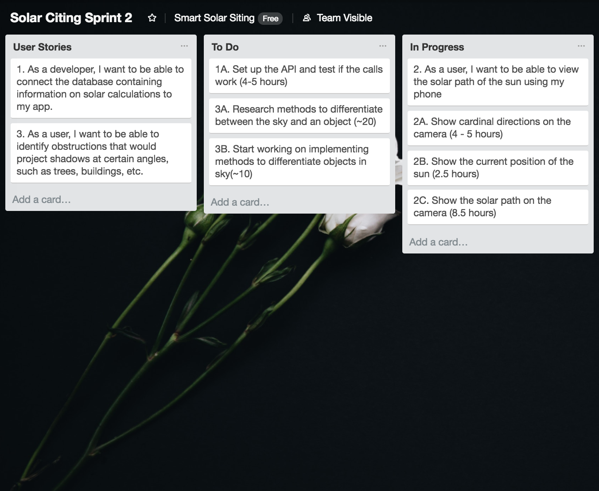

**Scrum Times**

Tuesday 10:00 - 10:20 - Lecture theatre

Thursday 10:00 - 10:20 - Lecture theatre

Friday 13:00 - 13:20 - Baskin 316